**Image 1: Complete image**

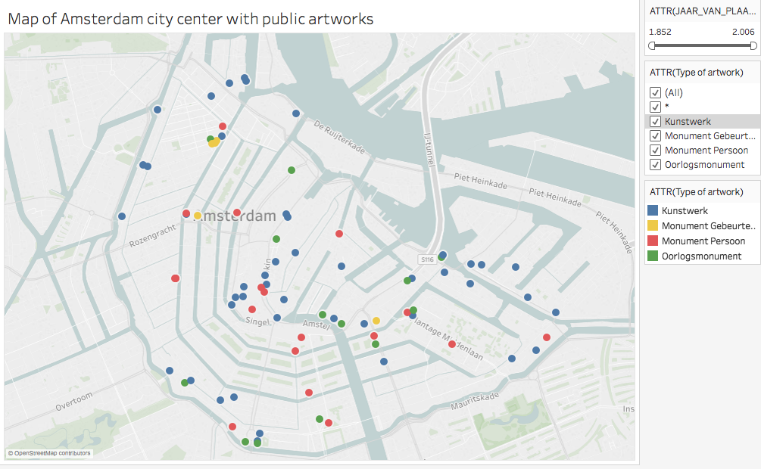

**Image 2: Artworks placed before 1950**

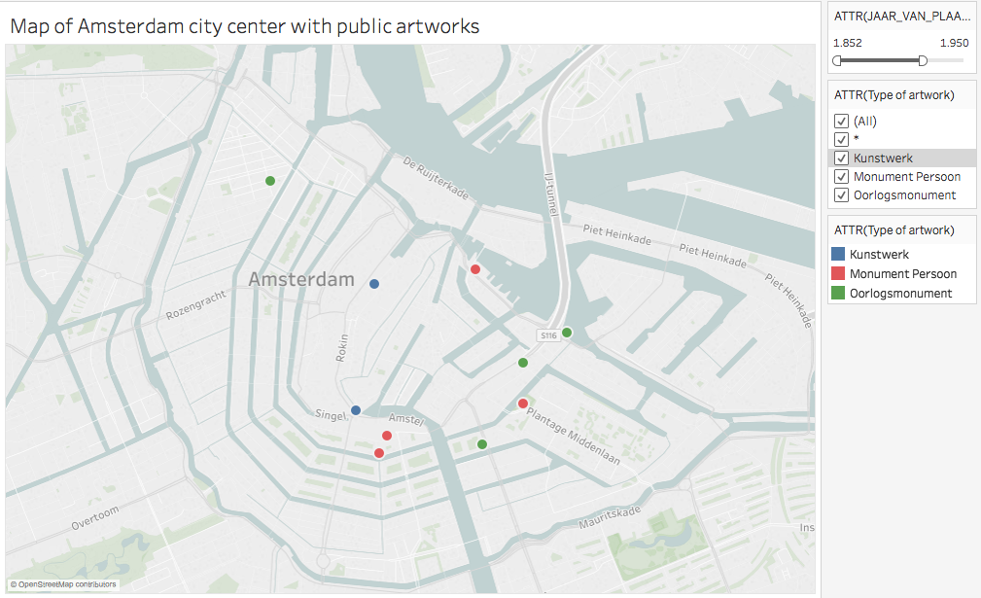

**Image 3: Artworks placed after 1950**

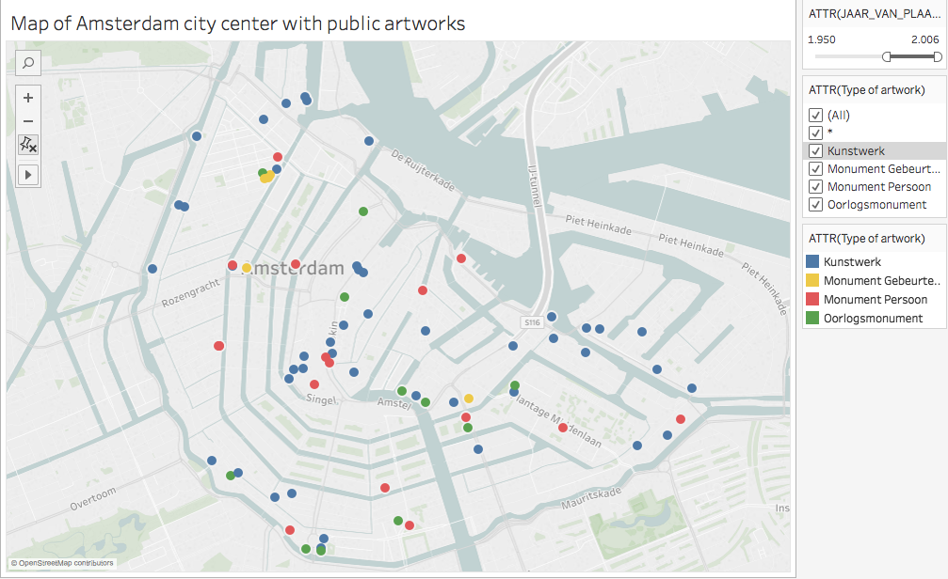

**Image 4: All monuments in Amsterdam**

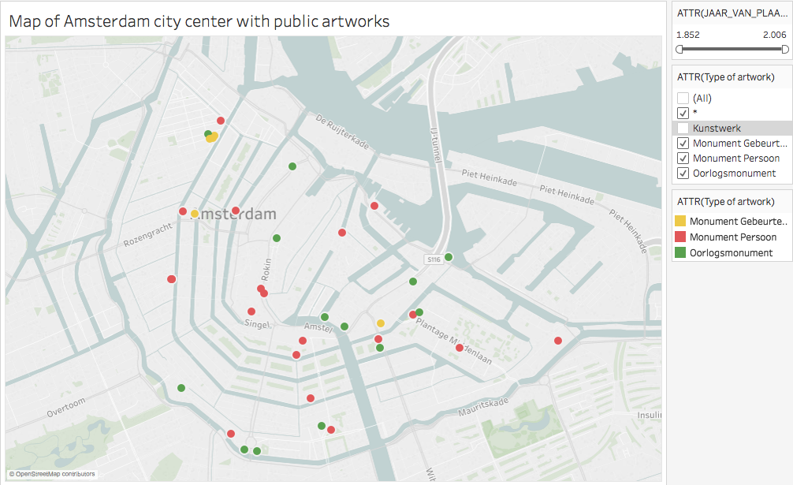

**Image 5: Close up of the map**

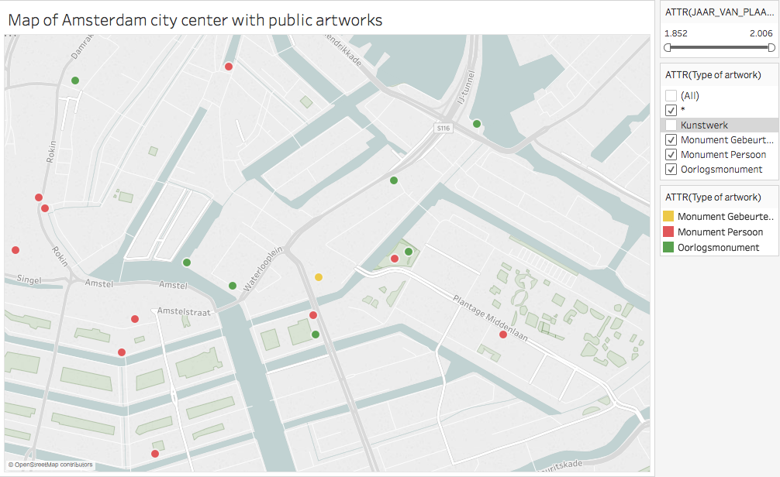

**Image 6: Nationaal Monument or Monument op de Dam on Damsquare**

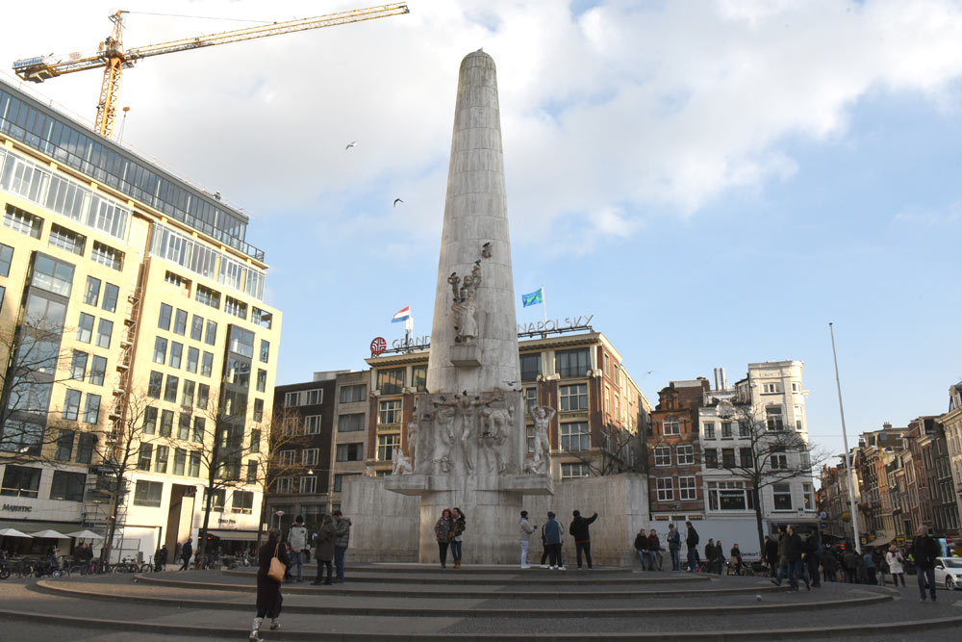

**Image 7: Statues of Rembrandt on Rembrandtplein**

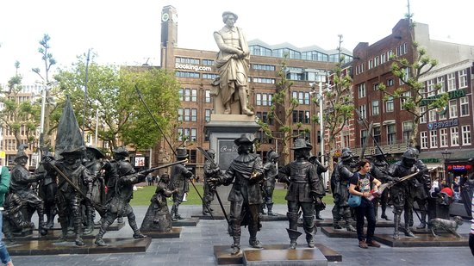

**Image 8: Statues of Johnny Jordaan and Tante Leen in De Jordaan**

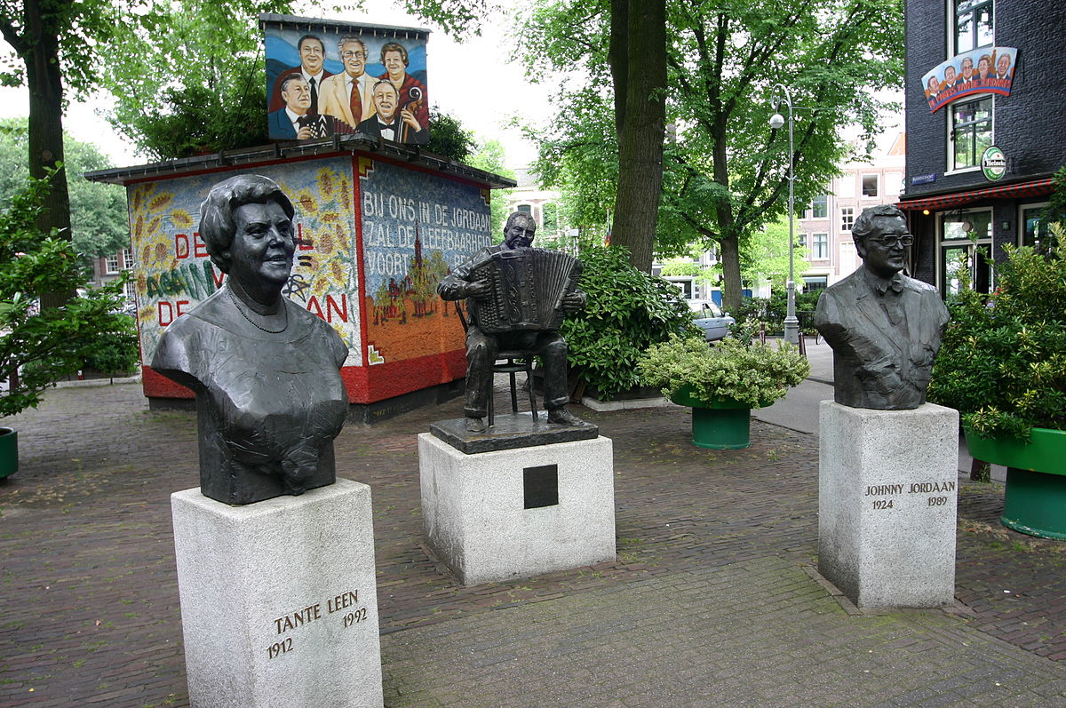

**Image 9: ‘Oorlogsgedenkteken Fusillade’ in Eerste Weteringplantsoen**

